Lab 2 Assignment Submission Instructions:

1. Please post screen shots of your “Cygwin” window, with the command “whoami”, and its output response

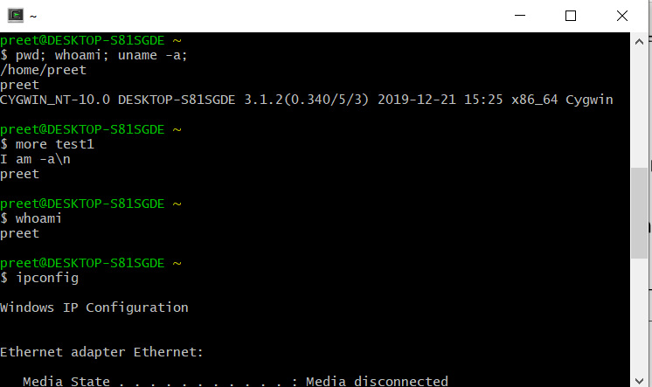

1. On your Linux session, please execute the following steps.
   1. cd /etc

Ans: This **command cd** /**etc** changes directory to the directory specified after the slash /. The /**etc** refers to a folder in the root called **etc**. If the **linux** user was inside the /**etc** folder, typing **cd** / would bring the user to the root

* 1. Explain what you see with this command: “ls *”

**Ans: ls** with no option list files and directories in bare format where we won’t be able to view details like file types, size, modified date and time, permission and links etc.

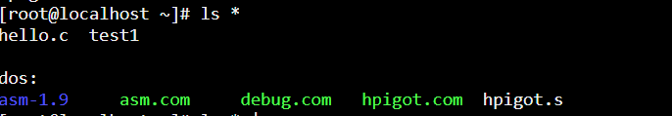

* 1. What is the difference between: “ls *” vs “ls * | more”?

Ans: There is 2 Answers. **ls** is standing for listing directories and files under a directory. In your situation, **ls** (without a directory argument) is going to list directories and files under the current directory(pwd). The other **command**, **ls** / is going to list files and directories under the root directory which is / .

